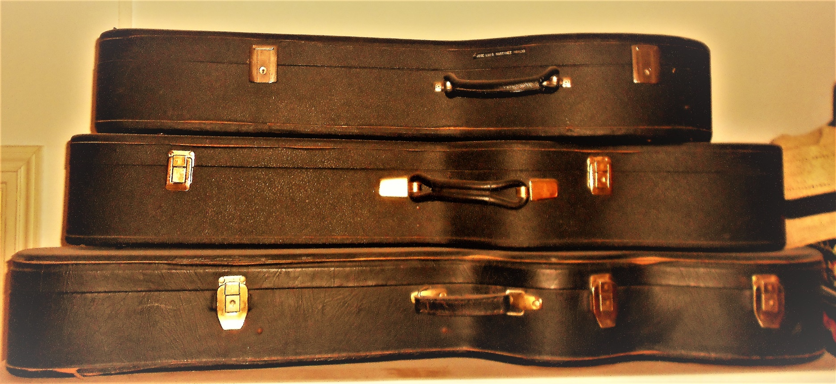

José Luis Martínez’s Repertoire
Different performance options, from solo guitar to guitar and orchestra.

Contact: Viviana Ball Ruiz
vivimball@gmail.com

Spanish Renaissance
Recercada sobre la romanesca by D. Ortiz
Pavana by D. Pisador
Fantasía que contrahaze la harpa de Ludovico by A. de Mudarra
Fantasías, Pavanas, Gallardas, Diferencias, and other pieces by the authors of the Spanish Vihuelistas School of the 16th century, like Milán, Narváez, Pisador, Fuenllana, Mudarra and Ortiz can be performed with a vihuela or a guitar.

Solo Guitar
Baroque
Suites for laud by J.S. Bach
Folies d’Spangne by Marin Marais
Danzas españolas by Gaspar Sanz and Santiago De Murcia

Classical- Romantic
Sonatas, Variaciones y Fantasías by Fernando Sor

Romantic
Recuerdos de la Alhambra
Capricho Arabe by Francisco Tárrega
Mazurcas
And other compositions

Rumores de la caleta
Mallorca by Isaac Albéniz
Sevilla

Danzas Españolas

Solo Guitar
And other compositions by Enrique Granados
Serenata Española
And other compositions by Joaquín Malast

20^{t th} & 21 ^{st} Century
Sonata for Guitar by Antonio José
Sonata Op. 61 by Joaquín Turina
Sonatina Maridional by Manuel M. de Ponce
Suite Castellana, Madroños y Nocturno by Federico
Moreno torroba
Pinceladas Nocturnas
(Homenaje a Vincent Van Gogh) by Ernesto Cordero
Rio de Luz
Amistad
Desde que te conocí
Giga Emiliana
Pez by José Luis
Viviana Martínez Moreno
Marios
Reflejos
Partida Doble
Duos
Flute and Guitar Duo
Suite for flute and basso continuo in Do mayor by J.S. Bach
Habaneras by M. Ravel
English Suite by Duarte
Romanian Folk Dances by Béla Bartók
Vals y Fuga
Duos
Amistad by José Luis
Viviana Martínez Moreno

Classic and Flamenco Guitar Duo
Entreacto de la vida breve
La danza del fuego by Manuel de Falla
Canción del fuego fatuo
Homenaje a F.G. Lorca by José Luis
Martínez Moreno
Musical arrangement of popular songs like:
Tico tico
La luna y el toro
La Vikina
En mi viejo San Juan
Leyenda del tiempo, Homenaje a Camarón de la Isla
ensemble
Classical Ensemble
Marios
Hermanos Becquer
Partida Doble
Giga Emiliana
Brenan
Vals de Ávila
La soledad y la montaña by José Luis
Amistad Martínez Moreno
​Vals en mi menor
Cambio de Aires
Desde que te conocí
Viviana
This can be performed with local musicians that accompany José Luis’s fist guitar. Scores are provided by us in time to be studied by the musicians. Scores are written for first guitar, second guitar, flute, clarinet, percussion, electric bass and chamber orchestra with metals.
ensemble
Jazz Ensemble
Marios
Hermanos Becquer
Partida Doble
Giga Emiliana
Brenan
Vals de Ávila
La soledad y la montaña by José Luis
Amistad Martínez Moreno
​Vals en mi menor
Cambio de Aires
Desde que te conocí
Viviana

This can be performed with local musicians that accompany José Luis’s fist guitar. Scores are provided by us in time to be studied by the musicians. Scores are written for first guitar, second guitar, saxophone, clarinet, percussion and electric bass.
Baroque
Guitar and Orchestra

Concierto en Re
Concierto en Sol by Antonio Vivaldi
(dos guitarras y orquesta)

Classical- Romantic

Concierto en La mayor by Mauro Giuliani
Concierto para guitarra by Ferdinando Carulli

20^{t th} & 21 ^{st} Century

Concierto de Aranjuez
Fantasía para un Gentilhombre by
Guitar and Orchestra

Concierto para una Fiesta Joaquín Rodrigo

Concierto Madrigal
(dos guitarras y orquesta) by Joaquín Rodrigo
Concierto Andaluz
(cuatro guitarras y orquesta)
Concierto para Guitarra y Orquesta by Ernesto Halffter
Concertino en La menor by Salvador Bacarisse
Concierto de la Bahía by Luis Barroso
Ballet para Guitarra y Orquesta by José Nieto
Suite Indiana
(two guitars and orchestra) by Jorge Cardoso
Concerto for Guitar and Orchestra by Heitor Villa-lobos
Antillano
Concert for Guitar and Orchestra by Ernesto Cordero
Guitar Concerto Op. 67 by Malcom Arnold
From Yesterday to Penny Lane by Leo Brouwer
For more information about repertoire, prices and other possibilities, please contact us at:
vivimball@gmail.com jlm@joseluismartinez.com
www.jose luismartinez.com

